**Aim**

To design and deploy a simple cloud-based application for managing the Property Buying & Rental process in Chennai city using Zoho Creator, thereby demonstrating Software as a Service (SaaS).

**Procedure**

1. **Login to Zoho Creator**
   * Open Zoho Creator and sign in with your Zoho account.
2. **Create a New Application**
   * Click **Create Application → From Scratch**.
   * Name it: **Property Buying & Rental System**.
3. **Design the Form**
   * Create a form titled **Property Buying & Rental Form**.
   * Add fields for **Property Details, Owner Details, and Payment Information** (as listed above).
4. **Create Reports (Views)**
   * Generate a **Property Listings Report** to display all properties available for sale/rent in Chennai.
   * Add filters based on **Location, Price Range, and Property Type**.
5. **Add Workflow (Optional)**
   * Configure an email/SMS notification to the property owner when a buyer/tenant shows interest.

Property Buying & Rental Form:

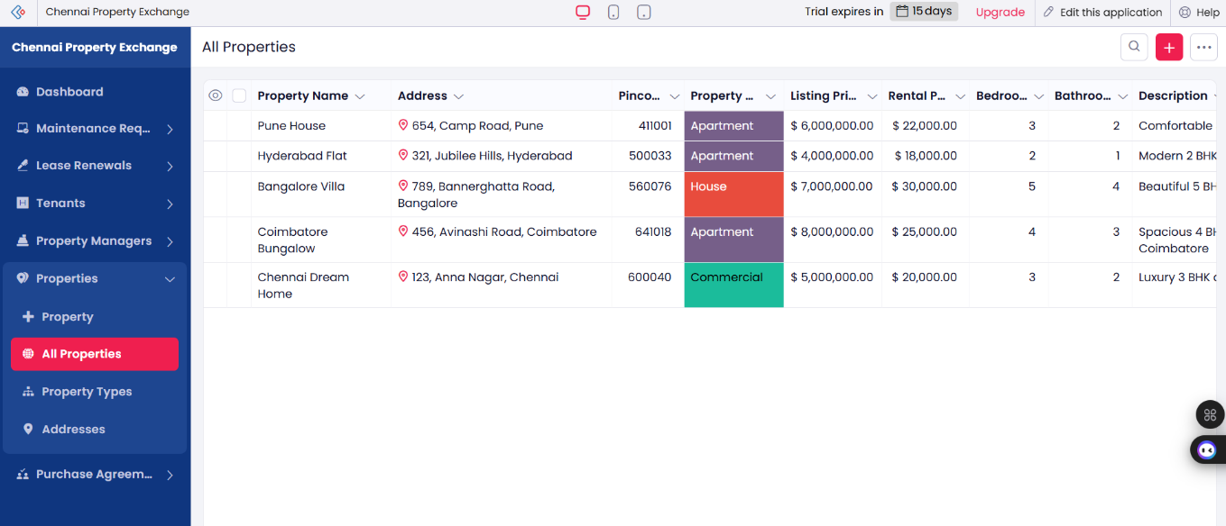

**Result**

* A **Property Buying & Rental System** was successfully created and deployed on Zoho Creator.
* Users can add property details for sale/rent in Chennai, and buyers/tenants can view available properties.
* The system helps manage property listings, buyer/renter information, and payment status efficiently.
* Being hosted on Zoho’s cloud, the application demonstrates **Software as a Service (SaaS)** by providing global accessibility and scalability.